SAMPLE PHOTO CAPTIONS TO ACCOMPANY PHOTO OF WINNER/CLASS

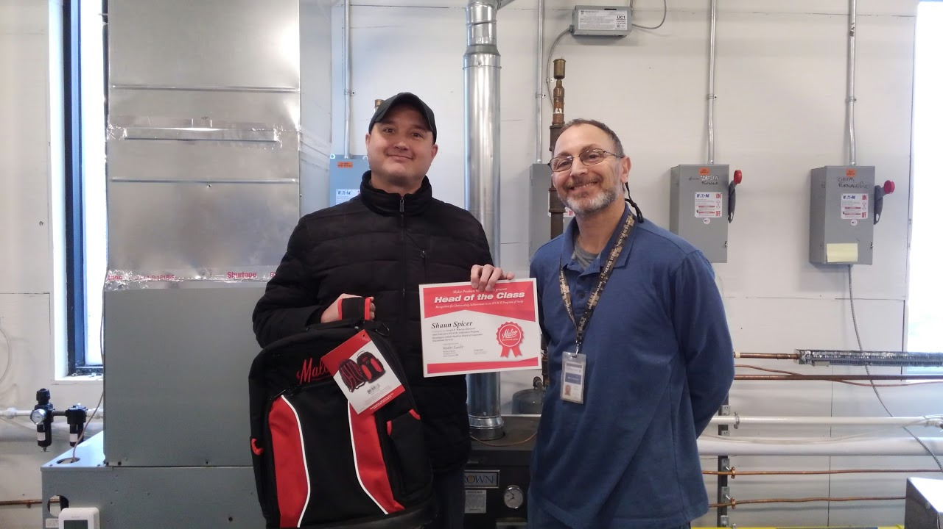
[STUDENT NAME], pictured with instructor [INSTRUCTOR NAME] from [SCHOOL/PROGRAM NAME], was recognized as a top student through Malco’s “Head of the Class” program. [STUDENT NAME] received a free tool gift and certificate, and the entire graduating class received Malco caps.

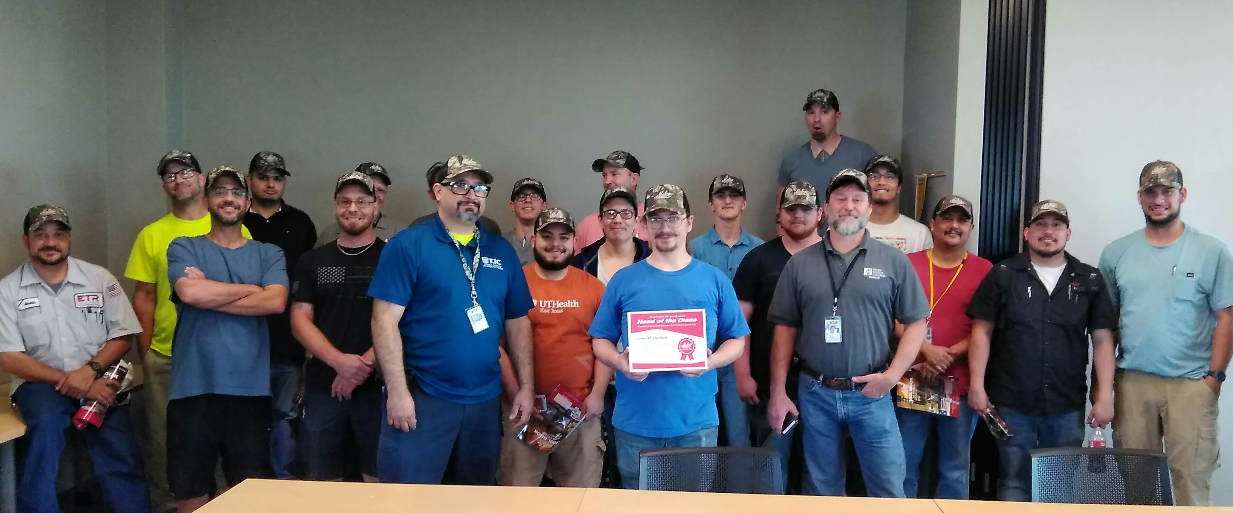
[SCHOOL/PROGRAM NAME] students were recognized by Malco Tools through the company’s annual “Head of the Class” program, which honors graduating classes of trade education students. Top student [STUDENT NAME] received a free tool gift from Malco, and the entire class received Malco caps.

